Question 1
--Q1. List top 5 customers by total order amount.
--Retrieve the top 5 customers who have spent the most across all sales orders. Show CustomerID, CustomerName, and TotalSpent.

select Top 5 o.customerid, c.name , sum(o.totalAmount) as total_spent
from salesorder o
left join customer c
on o.customerid = c.CustomerID
group by o.CustomerID , c.name
Order by total_spent desc
output:
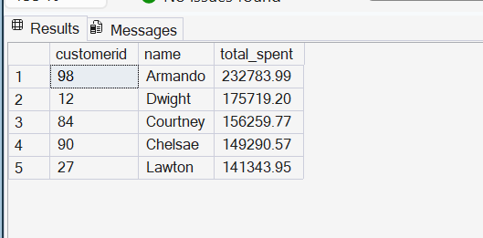

Question 2
--Q2. Find the number of products supplied by each supplier.
--Display SupplierID, SupplierName, and ProductCount. Only include suppliers that have more than 10 products.

select s.SupplierID, s.name, Count(Quantity) as ProductCount
From Supplier s
left join purchaseorder po
on s.SupplierID = po.SupplierID
left join PurchaseOrderDetail pod
on po.OrderID = pod.OrderID
group by s.SupplierID , s.name
having count(quantity) >=10
Output :
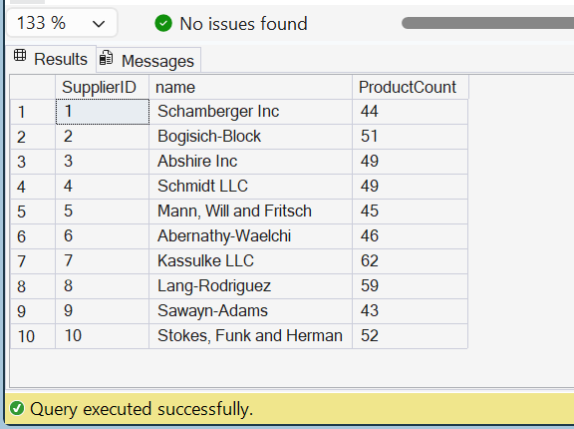

Question 3:
--Q3. Identify products that have been ordered but never returned.
--Show ProductID, ProductName, and total order quantity.

select p.ProductID , p.Name , count(sod.quantity)
From SalesOrderDetail sod
left join product p
on sod.productid = p.ProductID
where sod.productid not in ( select productid from returndetail)
Group by p.productid, p.name

Output:
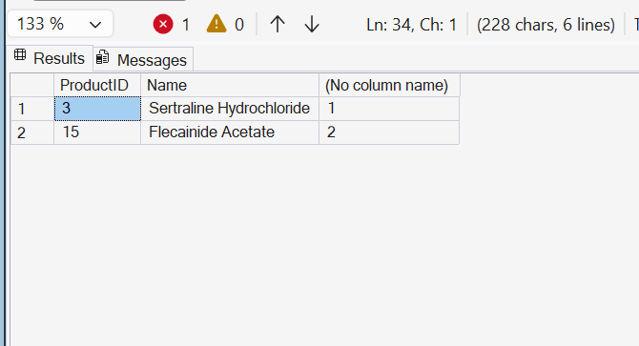
Question 4
--Q4. For each category, find the most expensive product.
--Display CategoryID, CategoryName, ProductName, and Price. Use a subquery to get the max price per category.

select c.categoryid, c.name as categoryname, p.name productname, p.price
from product p
inner join category c
on p.CategoryID = c.CategoryID
where p.price = (select max(p2.price) from Product p2
where p2.CategoryID = p.CategoryID)
output:
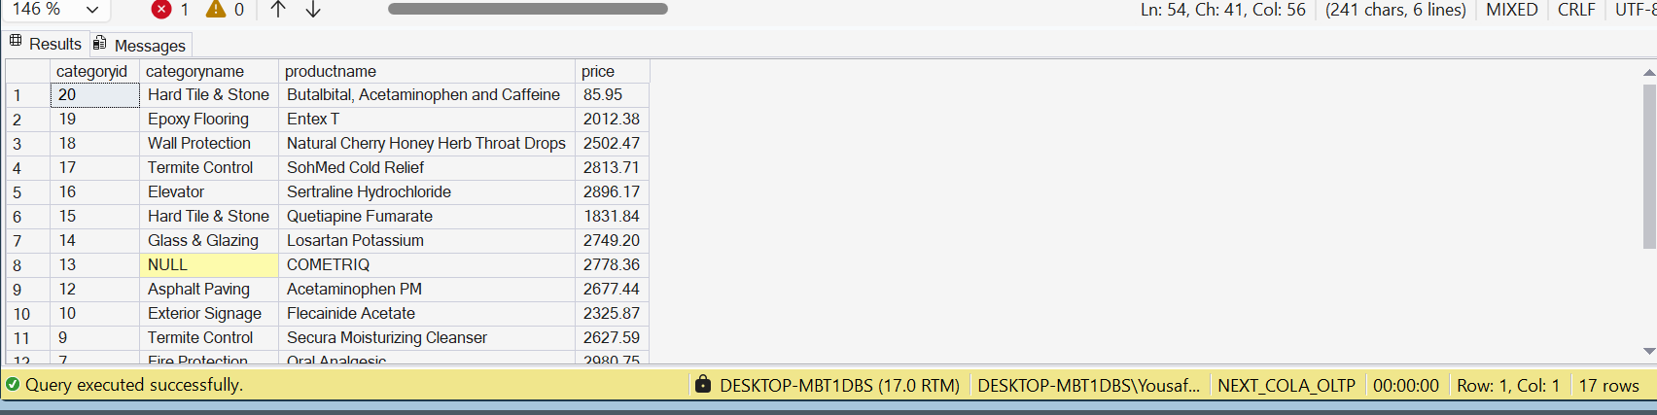

Question 5
--Q5. List all sales orders with customer name, product name, category, and supplier.
--For each sales order, display:
--OrderID, CustomerName, ProductName, CategoryName, SupplierName, and Quantity.

SELECT
so.OrderID,
c.Name AS CustomerName,
p.Name AS ProductName,
cat.Name AS CategoryName,
sp.Name AS SupplierName,
sod.Quantity
FROM salesorder so
left join customer c
on so.CustomerID = so.CustomerID
inner join SalesOrderDetail sod
on so.OrderID= sod.OrderID
inner join Product p
on sod.ProductID = p.ProductID
inner join Category cat
on p.CategoryID = cat.CategoryID
inner join PurchaseOrderDetail pod
on pod.ProductID = p.ProductID
inner join PurchaseOrder po
on pod.OrderID = po.OrderID
inner join supplier sp
on sp.supplierid = po.supplierid
ouput
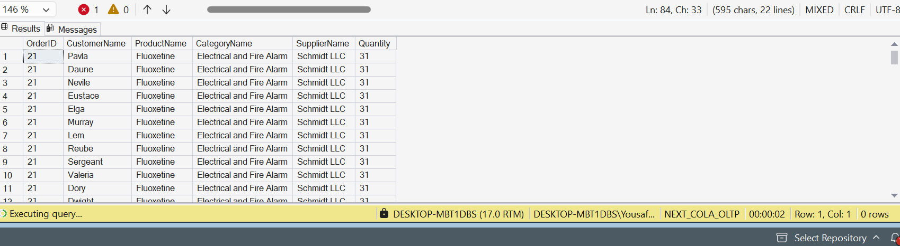

question 6
--Q6. Find all shipments with details of warehouse, manager, and products shipped.
--Display:
--ShipmentID, WarehouseName, ManagerName, ProductName, QuantityShipped, and TrackingNumber.

Select s.shipmentid, l.name as WarehouseName, e.name as ManagerName,
p.name as ProductName, sd.quantity as QuantityShipped, s.trackingnumber
from shipment s
inner join warehouse w
on s.WarehouseID = w.WarehouseID
inner join location l
on w.LocationID = l.LocationID
left join employee e
on w.ManagerID = e.EmployeeID
inner join shipmentdetail sd
on s.ShipmentID = sd.ShipmentID
inner join product p
on sd.ProductID = p.ProductID

-- Q7. Find the top 3 highest-value orders per customer using RANK(). Display CustomerID, CustomerName, OrderID, and TotalAmount.

select CustomerID, CustomerName, OrderID, TotalAmount
from (
select c.customerid, c.name as CustomerName,
so.orderid, so.totalamount,
rank() over(partition by c.customerid order by so.totalamount desc) as rnk
from salesorder so
inner join customer c
on so.customerid = c.customerid
) as rnk_tbl
where rnk <= 3

-- Q8. For each product, show its sales history with the previous and next sales quantities (based on order date). Display ProductID, ProductName, OrderID, OrderDate, Quantity, PrevQuantity, and NextQuantity.

select ProductID, ProductName, OrderID, OrderDate, Quantity,
lag(Quantity) over(partition by ProductID order by OrderDate) as PrevQuantity,
lead(Quantity) over(partition by ProductID order by OrderDate) as NextQuantity
from (
select p.productid, p.name as ProductName,
so.orderid, so.orderdate, sod.quantity
from salesorderdetail sod
inner join product p
on sod.productid = p.productid
inner join salesorder so
on sod.orderid = so.orderid
) as sales_hist

